Library Manager 4.51

A complete solution for efficient management of a Library.

Features:

- Issue Books
- Search Books
- Simple Search
- Advance search
- Add New Item
- Add New Category

- Check Account
- Return Books
- List All
- Check Return Date

##Issue Books

Double click on the Item ID of the particular Item to issue it.
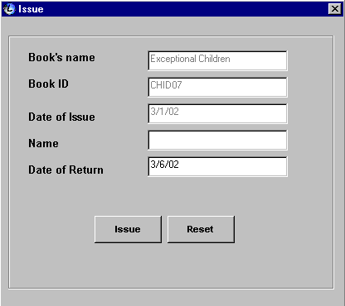
##Simple Search

Select the category from which you want to choose a particular item.

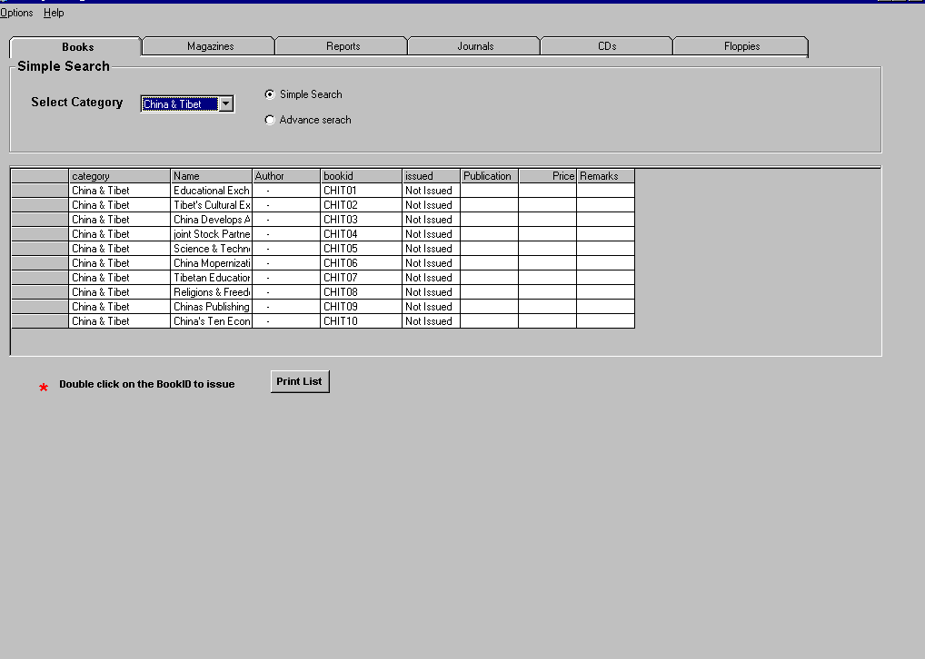

##Advance Search

Search a particular item by entering either it’s Name, ID or Author’s name and click Go.
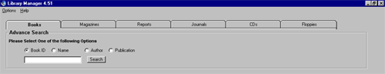

##Add New Item

Select ‘Add New’ from Options menu and give details.

Add new Category

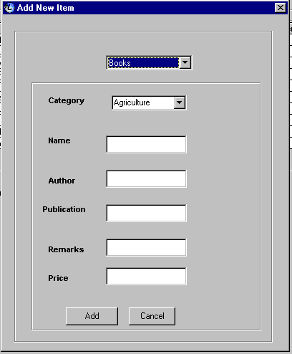

##Add New Category

Select ‘Add New’ from Options menu and select ‘Add Category’ from Category drop down menu.
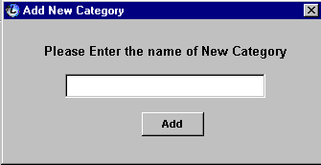

##Return Books

Select ‘Return’ from Options menu and fill either the Item Name or Item ID.
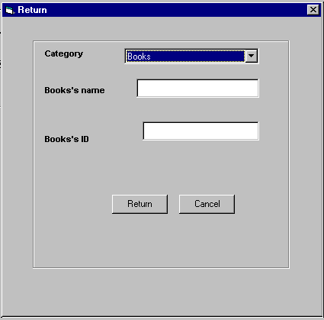

##Check Account

Select ‘Check Account’ from Options menu and enter the name of the Individual to check the account.
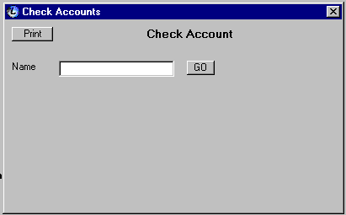

##Delete Item

Select ‘Delete Item’ from Options menu and enter the Name or ID of item to delete it permanently.
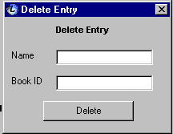

##List All

It lists the entire books in Library.
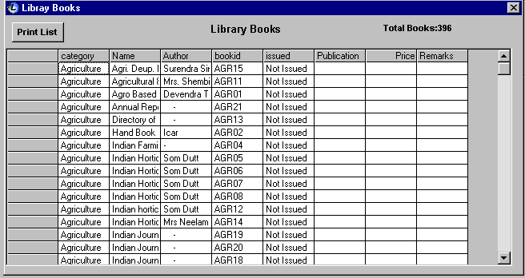

##Check Return Date

This Feature checks return date of Items
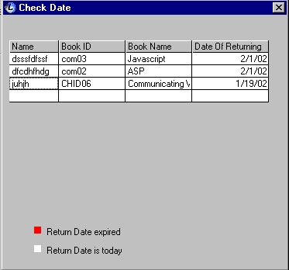

## Search Books

You can search books using following options:
- Simple Search
- Advance Search

# Issue Books
# Simple Search
# Advance Search
# Add New Item
# Add New Category
# Return Books
# Check Account
# Delete Item
# List All
# Check Return Date
# Search Books

